**EURUSD Weekly Analysis (29th July – 2nd August, 2024)**

Willy Mwangi Kiarie

Institute of Inner Circle Trader (ICT)

SAT, 3rd August 2024

**Table of Contents**

Abstract 3

1.0 Introduction 4

2.0 Objectives 4

3.0 Methods 4

4.0 Results 5

a) Monday 6

b) Tuesday 7

c) Wednesday 8

d) Thursday 9

e) Friday 10

5.0 Discussion 11

Bullish Movement (Post-12:00pm Data Releases) 12

Bearish Movement (Post-3:15pm Data Releases and Later Events) 13

Market Interpretation and Reactions: 15

Bearish Trend (Morning and Early Afternoon) 16

Bullish Trend (Late Afternoon and Evening) 17

Market Interpretation and Reactions 18

3:30pm USD News: 18

Market Interpretation and Reactions 19

Combined Impact 20

6.0 Recommendations 20

7.0 Conclusion 21

8.0 References 22

9.0 Appendices 23

# Abstract

The EUR/USD Weekly Analysis report for the period of July 29th to August 2nd, 2024, details the performance of the currency pair using a 5-minute chart from MetaTrader 5. It outlines key market movements and trends for each day, influenced by economic indicators and news events. The report identifies daily open, high, low, and close values, and examines the effects of major news, such as the Federal Fund Rate announcement and Non-Farm Employment Change data, on market behavior. Monday through Thursday saw mixed trends with specific Optimal Trade Entry (OTE) times highlighted for traders. Significant insights include the bearish trend on Tuesday due to German CPI and US consumer confidence data, and Wednesday's bullish-to-bearish reversal triggered by Eurozone inflation data and US employment reports. The analysis culminates on Friday with a bullish trend driven by weaker-than-expected US labor market data. The report concludes with recommendations for utilizing advanced analytical tools and psychological discipline in trading, and summarizes key findings, providing a thorough evaluation of the EUR/USD pair’s performance.

# 1.0 Introduction

The EUR/USD pair is the most traded currency pair in the foreign exchange (Forex) market. It represents the exchange rate between the Euro (EUR) and the US Dollar (USD). Specifically, it shows how many US Dollars are needed to buy one Euro. The pair is affected/influenced by several factors e.g. Central bank policies, economic data, political events, market sentiment, interest rate differentials, trade balances, inflation rates, and other global economic conditions such as the oil prices, financial crises etc. This report evaluates the weekly performance of Forex EUR/USD pair from Monday 29th July to Friday 2nd August 2024 using a 5 minute chart obtained from MetaTrader 5 platform.

# 2.0 Objectives

1. To identify the open, high, low, and close of the week.
2. To find out the general trend of the week i.e. whether the week was bearish or bullish.
3. To analyze the effects of high impact news on the EUR/USD pair.

# 3.0 Methods

The following steps were used to conduct EUR/USD pair weekly analysis:

- Logged into the MetaTrader 5 platform.

- Used the 30 minutes chart to observe the weekly general trend

- Used markers to delineate the Asian Range (2:00 AM – 7:00 AM EAT) where, the vertical lines were used to mark the duration while the horizontal lines were used to mark the Asian High and Asian Low of every day of the week (apart from Saturday & Sunday, as currencies are not traded on the weekend).

- The algorithms (Open, High, Low, & Close) for each day were recorded.

- Comments were made on the 5 – minutes charts and screenshots taken.

- Visited <https://www.forexfactory.com/calendar> website for fundamentals (News).

# 4.0 Results

|  |  |  |  |  |
| --- | --- | --- | --- | --- |
| **Mon 29th July to Fri 2nd Aug, 2024 Algorithms** | | | | |
|  | **Open** | **High** | **Low** | **Close** |
| **Monday** | 1.08621 | 1.08700 | 1.08027 | 1.08210 |
| **Tuesday** | 1.08236 | 1.08359 | 1.07980 | 1.08138 |
| **Wednesday** | 1.08252 | 1.08496 | 1.08015 | 1.08248 |
| **Thursday** | 1.08329 | 1.08355 | 1.07775 | 1.07901 |
| **Friday** | 1.07954 | 1.09267 | 1.07860 | 1.09098 |

## Monday

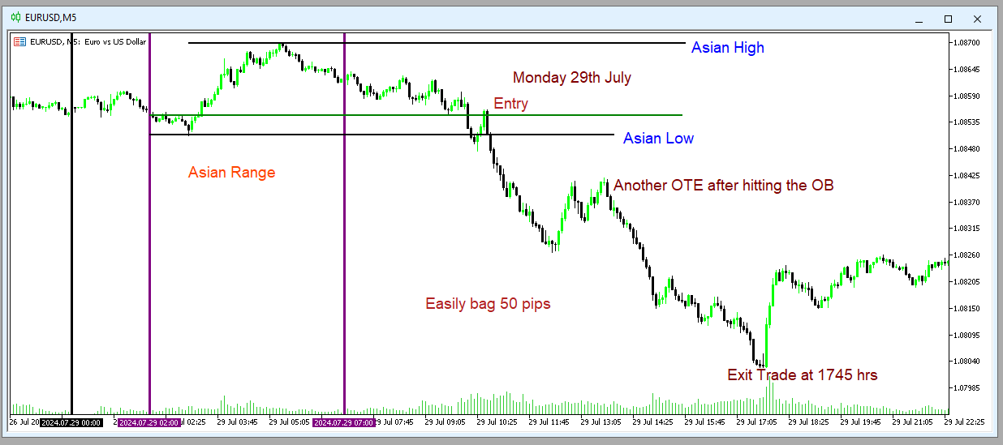

The following inferences can be drawn from the above Monday 5 – Minute chart:

1. The midnight New York Market Opened on a high note, 1.08621, indicating a stronger USD currency over the Euro.
2. A bearish candle was formed on this day with the Asian zone recording the High of the day, 1.08700, while the New York session formed the Low of the day, 1.08027.
3. Optimal Trade Entry (OTE) was best suited during the London Open session. That is, at 10:40 AM EAT, vindicating the ICT Silver Bullet Hour (3:00 AM – 4:00 AM EST).
4. Another OTE suited for traders was at 1345 hours EAT, just 15 before the New York Morning Open (7:00 AM EST).
5. Traders were supposed to exit trade at 1745 hours EAT since price action reversal usually take place during the London Close session (10:00 AM – 12 Noon EST).
6. With the right OTE, a trader was supposed to easily bag 50 pips.

## Tuesday

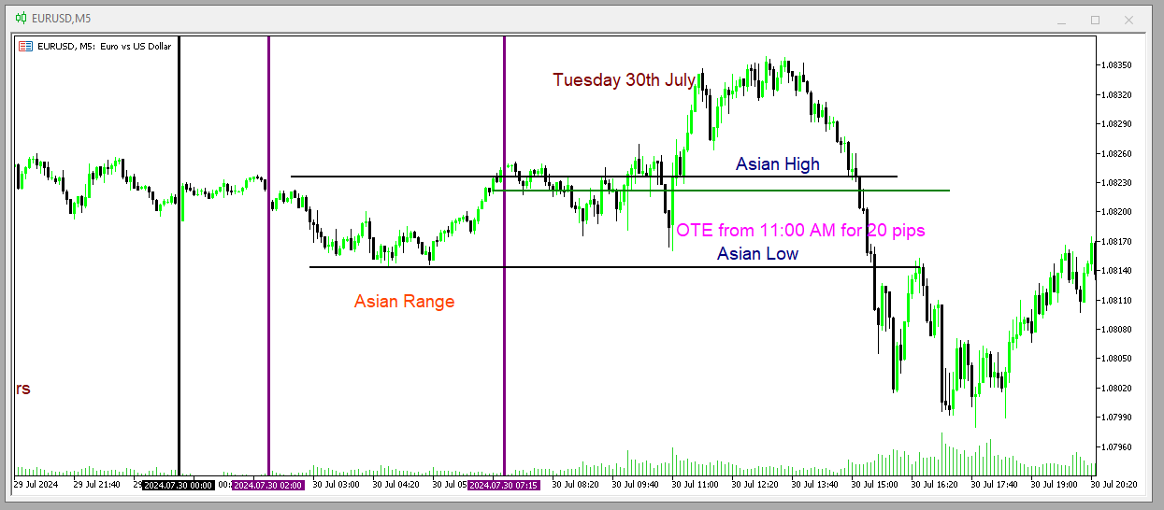

The following insights can be derived from the above, Tuesday 5-minutes chart:

1. The general trend was bearish. That is, accumulation during Asian zone, manipulation during London session, and distribution during New York session (ICT Power Of 3 concept).
2. OTE was best suited at 11:00 AM EAT (Within the Silver Bullet Hour Range).
3. The Market Opened at 1.08236 during the Asian Zone. On the other hand, the Market Closed at 1.08138 during the New York PM session.
4. The High of the day (1.08359) was reached during the London session while the Low of the day (1.07980) during the New York session.

## Wednesday

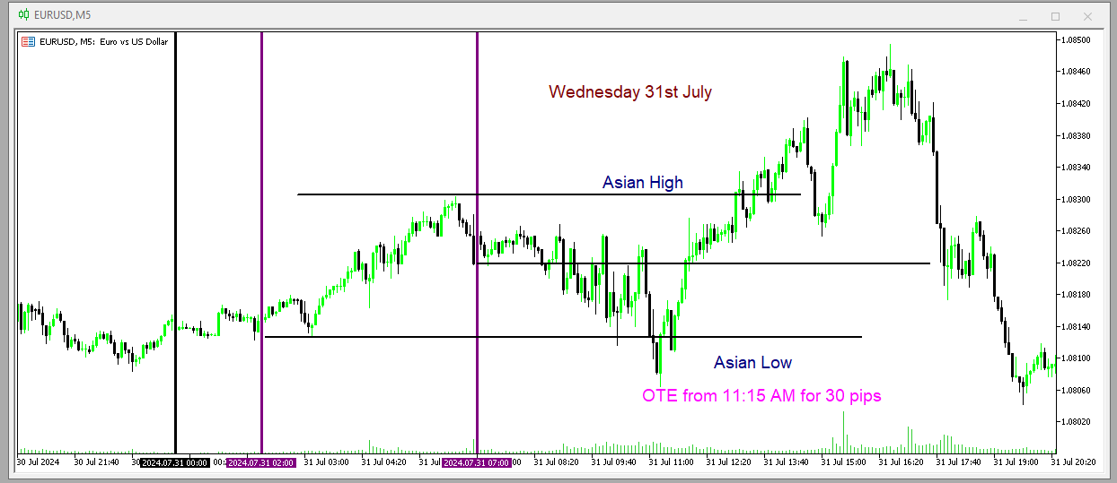

The above line chart offers the following insights and information about Wednesday’s Trade:

1. The Asian Range was bullish.
2. Manipulation took place in London Open session (2:00 AM to 5:00 AM).
3. Similarly, Judas Swing, famously known as “false run” occurred during the London Open session (9:00 AM to Noon EAT).
4. The right time for OTE was at 11:15 AM after the Low of the day has formed (1.08015). One could bag 30 pips easily.
5. It is also good to note that the Midnight New York Market Opened at 1.08252 and Closed Down at 1.08248. The ICT Power Of 3 formed.

## Thursday

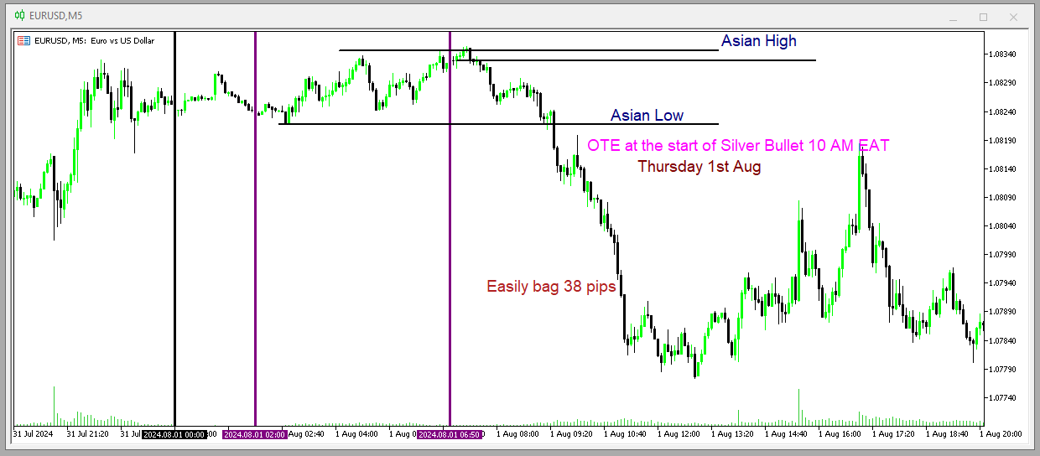

The following inferences can be derived from the above Thursday 5 – Minute Chart:

1. The daily candle was bearish.
2. The Market New York Midnight Opened (1.08329) at the end of Asian Range (7:00 AM EAT).
3. The High of the day (1.08355) was formed during the London session.
4. The Low of the day (1.08355) was formed during the New York session.
5. OTE was best suited at the beginning of the Silver Bullet Time. One could easily bag 38 pips, which are enough for the day according to ICT.
6. The London session FVG is VITAL as it is also used as OTE.

## Friday

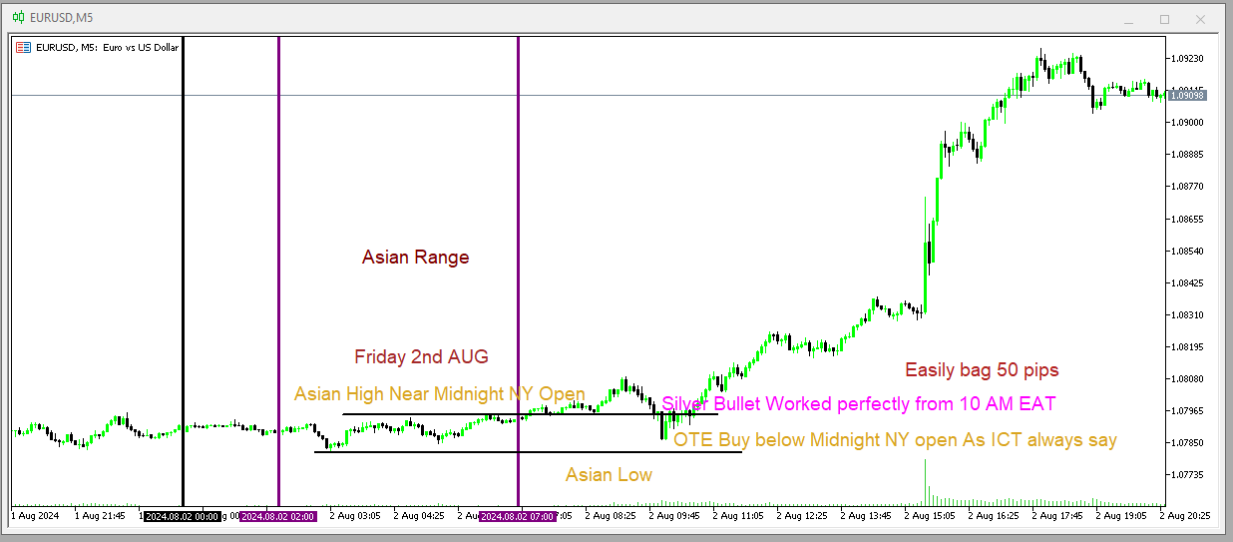

The above line chart offers the following insights:

1. The Asian Range was purely manipulation.
2. The London session formed Judas Swing or rather the Low of the day (1.07860).
3. OTE was EXACTLY at the beginning of the Silver Bullet Time (10:00 AM EAT). One could easily collect 50 pips.
4. The Market Opened at 1.07954 and Closed at 1.09098. Thus, implying that the market was Bullish
5. High of the day (1.09267) was reached during the New York session after the formation of an upward spike, influenced by high impact news (NFP).

# 5.0 Discussion

A report by IC Markets Global (2024) shows that the dollar remained strong due to absence of any major news. The Federal Fund Rate Target remained unchanged (5% to 5.5%) hence the bearish run. In addition, the ECB interest rate remained unchanged in July.

Tuesday general trend was Bearish due to the following reasons:

• **German Prelim CPI m/m (EUR)**

* **Actual: 0.3%**
* **Forecast: 0.3%**
* **Previous: 0.1%**

The actual German Consumer Price Index (CPI) matched the forecast, which was an improvement from the previous month. While this indicates moderate inflation in Germany, the fact that it met expectations rather than exceeding them might not have provided a strong boost to the Euro. Markets often react more strongly when economic indicators surpass forecasts. Thus, the data's neutral effect could leave the Euro vulnerable if stronger US data is released.

• **CB Consumer Confidence (USD)**

* **Actual: 100.3**
* **Forecast: 99.7**
* **Previous: 97.8**

The Conference Board (CB) Consumer Confidence index for the US was higher than both the forecast and the previous value. This indicates improving consumer confidence, which is a positive sign for the US economy. Strong consumer confidence can lead to increased spending and economic growth, which in turn can strengthen the US Dollar. Positive sentiment around the US economy could lead investors to favor the USD over the EUR, contributing to the bearish trend in the EUR/USD pair.

• **JOLTS Job Openings (USD)**

* **Actual: 8.18M**
* **Forecast: 8.02M**
* **Previous: 8.23M**

The Job Openings and Labor Turnover Survey (JOLTS) showed that job openings were slightly above the forecast but slightly below the previous month's figure. This indicates a robust job market in the US, which is generally positive for the USD. A strong job market suggests economic strength, which can attract investment and strengthen the currency.

The EUR/USD pair experienced bullish and then bearish movements on Wednesday due to the sequence and implications of various economic news releases and events. Let's break down how these affected the market:

**Bullish Movement (Post-12:00pm Data Releases)**

**12:00pm**

**EUR News:**

1. **Core CPI Flash Estimate y/y**
   * **Actual: 2.9%**
   * **Forecast: 2.8%**
   * **Previous: 2.9%**
2. **CPI Flash Estimate y/y**
   * **Actual: 2.6%**
   * **Forecast: 2.5%**
   * **Previous: 2.5%**

The Eurozone inflation data came in slightly higher than expected. This suggests that inflationary pressures are stronger, which might lead the European Central Bank (ECB) to consider more aggressive monetary tightening in the future. As a result, the Euro gained strength, leading to a bullish movement in the EUR/USD pair.

**Bearish Movement (Post-3:15pm Data Releases and Later Events)**

**3:15pm**

**USD News:**

1. **ADP Non-Farm Employment Change**
   * **Actual: 122K**
   * **Forecast: 147K**
   * **Previous: 155K**

The ADP employment data was weaker than expected, initially suggesting potential weakness in the US labor market. This might have initially contributed to some weakness in the USD.

**3:30pm**

**USD News:** 2. **Employment Cost Index q/q**

* **Actual: 0.9%**
* **Forecast: 1.0%**
* **Previous: 1.2%**

The Employment Cost Index was slightly below expectations, which might have reinforced the view of a less aggressive stance from the Federal Reserve regarding interest rate hikes.

**5:00pm**

**USD News:** 3. **Pending Home Sales m/m**

* **Actual: 4.8%**
* **Forecast: 1.4%**
* **Previous: -1.9%**

The Pending Home Sales data significantly exceeded expectations, indicating strong activity in the housing market. This data point suggested resilience in the US economy, which can support the USD.

**9:00pm**

**USD News:** 4. **Federal Funds Rate**

* **Actual: 5.50%**
* **Forecast: 5.50%**
* **Previous: 5.50%**

1. **FOMC Statement**
2. **9:30pm - FOMC Press Conference**

The Federal Reserve maintained the interest rate at 5.50%, as expected. However, the FOMC statement and subsequent press conference are crucial. If the Fed's tone was more hawkish than anticipated, suggesting potential future rate hikes or expressing concern about inflation, it would strengthen the USD.

**Market Interpretation and Reactions:**

* **12:00pm - 3:15pm:** The Euro strengthened due to the better-than-expected inflation data from the Eurozone, leading to a bullish EUR/USD movement.
* **3:15pm - 3:30pm:** Initially, weaker ADP employment and Employment Cost Index data could have led to some USD weakness, maintaining the bullish EUR/USD trend.
* **5:00pm - 9:00pm:** The much stronger Pending Home Sales data suggested strong economic activity in the US, leading to USD strength.
* **9:00pm - 9:30pm:** The FOMC's hawkish tone or hints at future rate hikes during the press conference could have significantly strengthened the USD, resulting in a bearish movement in the EUR/USD pair.

The EUR/USD pair's movement on Thursday can be explained by the sequence of economic news releases from both the Eurozone and the United States, influencing the general trend of the currency pair.

### Bearish Trend (Morning and Early Afternoon)

#### 10:15am

**EUR News:**

1. **Spanish Manufacturing PMI**
   * **Actual: 51.0**
   * **Forecast: 52.5**
   * **Previous: 52.3**

The Spanish Manufacturing PMI came in significantly below expectations and the previous month's value. This indicates a slowdown in the Spanish manufacturing sector, which can be seen as a negative indicator for the Eurozone economy, contributing to Euro weakness.

#### 11:00am

**EUR News:** 2. **Italian Monthly Unemployment Rate**

* **Actual: 7.0%**
* **Forecast: 6.8%**
* **Previous: 6.9%**

The Italian unemployment rate was higher than expected and the previous month's figure. Higher unemployment suggests economic weakness, adding further negative sentiment towards the Euro.

### Bullish Trend (Late Afternoon and Evening)

#### 3:30pm

**USD News:** 3. **Unemployment Claims**

* **Actual: 249K**
* **Forecast: 236K**
* **Previous: 235K**

The US unemployment claims were higher than expected, indicating more people filing for unemployment benefits. This suggests some softness in the US labor market, which can be seen as negative for the USD.

#### 5:00pm

**USD News:** 4. **ISM Manufacturing PMI**

* **Actual: 46.8**
* **Forecast: 48.8**
* **Previous: 48.5**

The ISM Manufacturing PMI came in well below expectations and the previous month's figure. A reading below 50 indicates contraction in the manufacturing sector, suggesting economic weakness in the US. This negative news could lead to USD weakness.

### Market Interpretation and Reactions

* **Bearish Phase (Morning and Early Afternoon):** The weaker-than-expected Spanish Manufacturing PMI and higher-than-expected Italian unemployment rate contributed to Euro weakness. This drove the EUR/USD pair lower, resulting in a bearish trend.
* **Bullish Phase (Late Afternoon and Evening):** The higher-than-expected US unemployment claims and significantly weaker ISM Manufacturing PMI pointed to economic weakness in the US. This data likely reduced investor confidence in the USD, causing it to weaken. As a result, the EUR/USD pair experienced a bullish reversal.

On Friday, the EUR/USD pair was entirely bullish due to a series of weaker-than-expected US economic data releases at 3:30pm. Let's examine each piece of data and how it contributed to the bullish trend for the EUR/USD pair:

### 3:30pm USD News:

1. **Average Hourly Earnings m/m**
   * **Actual: 0.2%**
   * **Forecast: 0.3%**
   * **Previous: 0.3%**

The average hourly earnings growth came in lower than expected. Wage growth is a key indicator of inflationary pressures and consumer spending power. Lower-than-expected earnings suggest weaker inflationary pressures and potentially less consumer spending, which can reduce expectations for aggressive interest rate hikes by the Federal Reserve. This is bearish for the USD.

1. **Non-Farm Employment Change**
   * **Actual: 114K**
   * **Forecast: 176K**
   * **Previous: 179K**

The Non-Farm Employment Change figure was significantly lower than forecasted and the previous month's value. This indicates a substantial slowdown in job creation, suggesting weakness in the labor market. A weaker labor market can dampen economic growth prospects and reduce the likelihood of future interest rate hikes by the Federal Reserve, which is bearish for the USD.

1. **Unemployment Rate**
   * **Actual: 4.3%**
   * **Forecast: 4.1%**
   * **Previous: 4.1%**

The unemployment rate increased to 4.3%, higher than the forecast and previous month's figure. An increasing unemployment rate suggests more slack in the labor market, which can also reduce inflationary pressures and economic growth expectations. This is another bearish factor for the USD.

### Market Interpretation and Reactions

* **Weaker Wage Growth (Average Hourly Earnings):** Lower-than-expected wage growth indicates less inflationary pressure, reducing the need for aggressive rate hikes.
* **Disappointing Job Creation (Non-Farm Employment Change):** A significant miss in job creation points to a weaker labor market and overall economic weakness.
* **Rising Unemployment Rate:** An increase in the unemployment rate suggests more economic slack and potential weakness in consumer spending and economic growth.

### Combined Impact

All three data points released at 3:30pm on Friday indicated a weaker US labor market and reduced inflationary pressures. This collectively diminishes the likelihood of aggressive monetary tightening by the Federal Reserve, leading to a bearish sentiment for the USD. As a result, the USD weakened across the board, and the EUR/USD pair experienced a bullish trend.

# 6.0 Recommendations

To enhance the accuracy and effectiveness of predicting the EUR/USD pair trends, it is recommended to leverage high-tech skills and advanced analytical tools such as Python, R Studio, and Excel. Utilizing techniques like time series analysis, linear regression, and Random Forest models can significantly improve the forecast of weekly algorithms based on historical and news data. Additionally, traders should prioritize the psychological aspect of trading, focusing on mastering emotions and controlling greed and fear. This can be achieved through disciplined trading practices, continuous education, and the implementation of strict risk management strategies.

# 7.0 Conclusion

This report successfully met its objectives by identifying the open, high, low, and close values for each trading day from Monday, 29th July to Friday, 2nd August 2024. The general trend for each day was analyzed, and the effects of high-impact news on the EUR/USD pair were thoroughly examined. By incorporating both technical and fundamental analyses, the report provided a comprehensive evaluation of the EUR/USD pair's performance throughout the week, offering valuable insights and actionable recommendations for future trading strategies.

# 8.0 References

<https://www.icmarkets.com/blog/ic-markets-europe-fundamental-forecast-29-july-2024/>

<https://www.forexfactory.com/calendar>

# 9.0 Appendices

**Fundamentals (News) Data**

1. **Monday News**

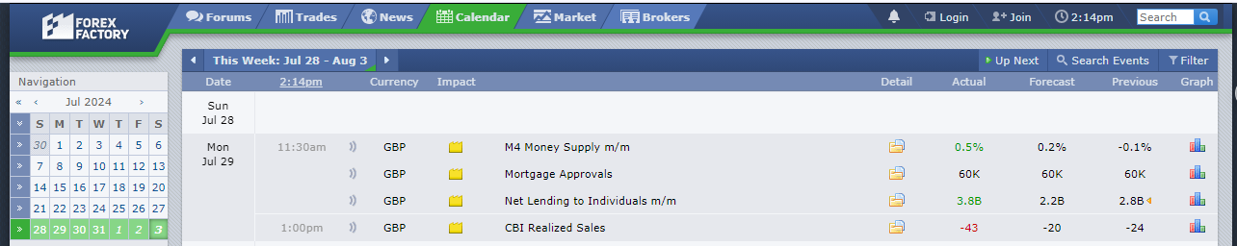

1. **Tuesday News**

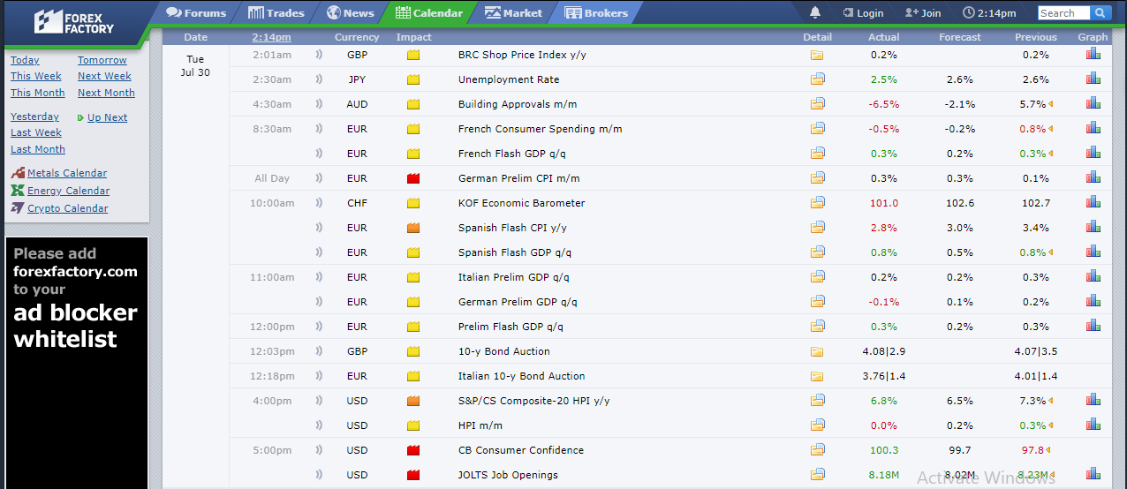

1. **Wednesday News**

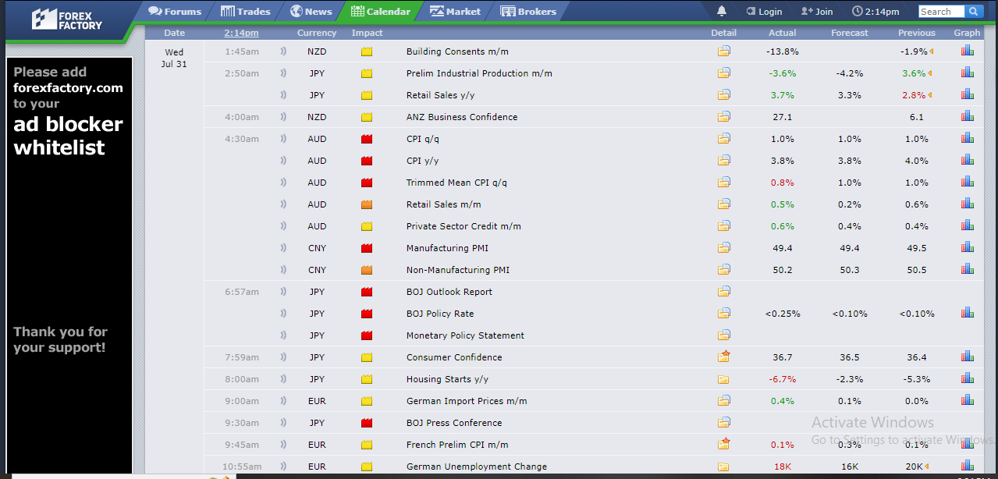

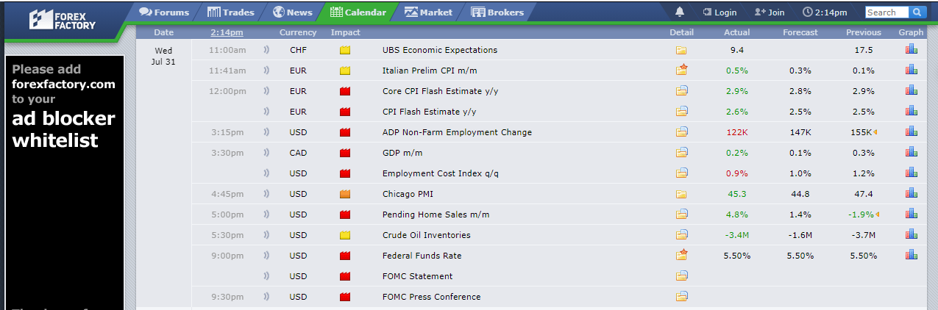

1. **Thursday News**

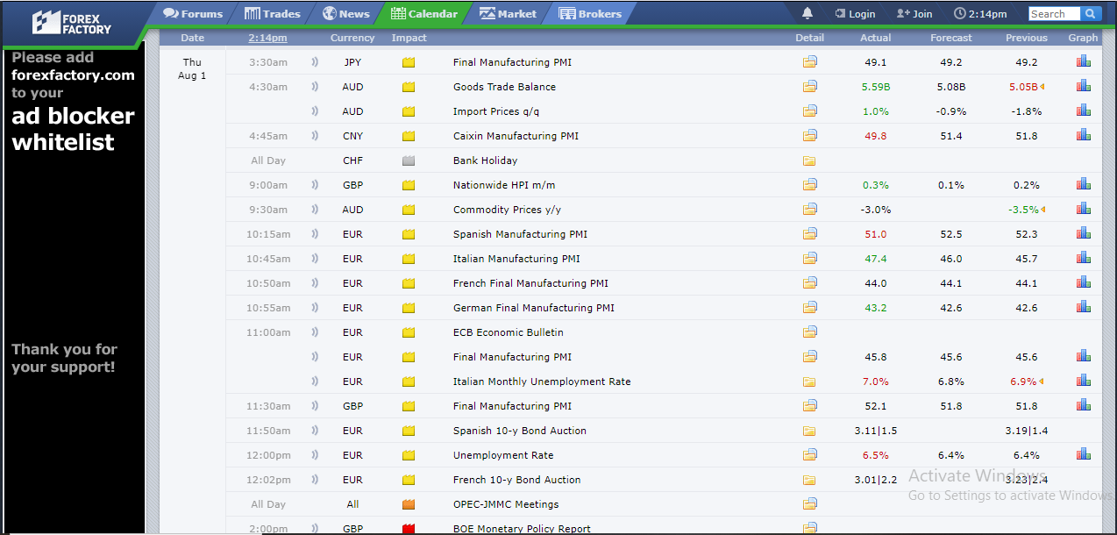

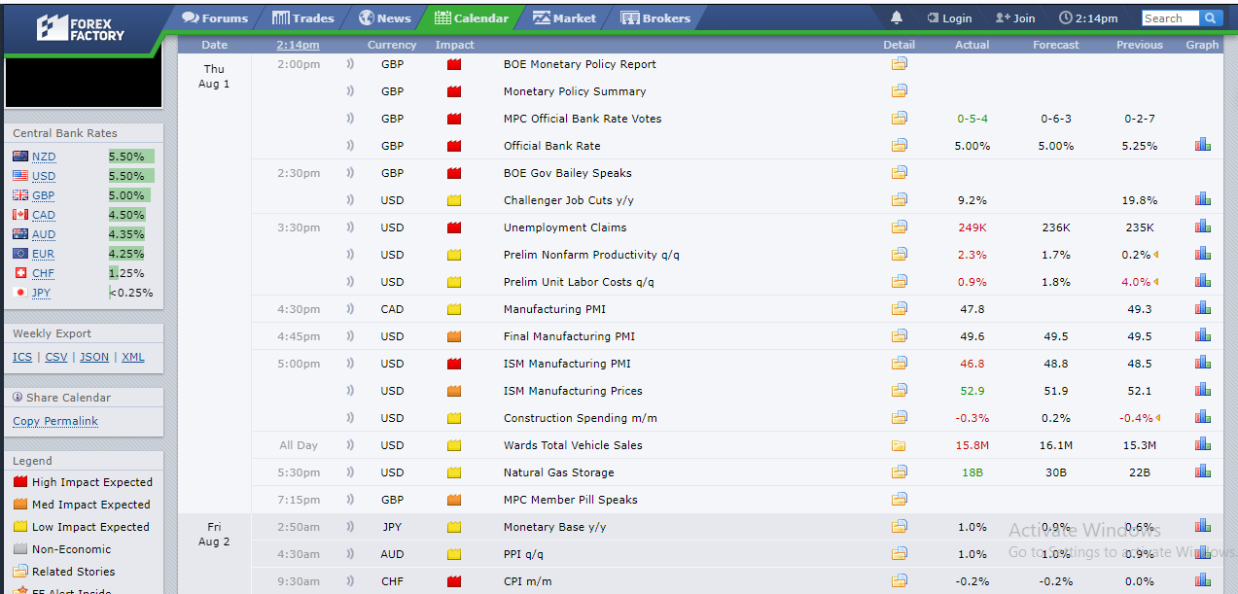

1. **Friday News**

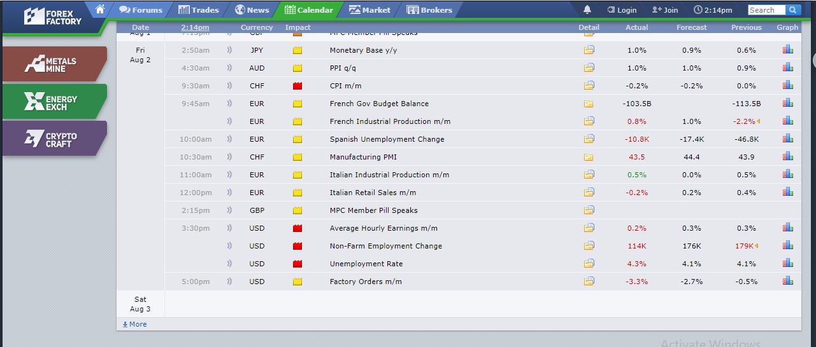

**Contact**

Email: [wmwangi890@gmail.com](mailto:wmwangi890@gmail.com)

Twitter: @Willymwangikia1